Enterprise SPFTWARE ENGINEERING DEVELOPMENT

Table of Contents

**1)** **Introduction** 2

**2)** **5 Ps of Software Development** 3

**2.1.** **Problem** 3

**2.2.** **Process** 5

**2.3.** **Project** 9

**2.3.1.** **Goal** 9

**2.3.2.** **Budget** 9

**2.3.3.** **Resources** 9

**2.3.4.** **CASE Tools** 11

**2.4.** **Product** 12

**2.4.1** **Functional Requirements** 13

**2.4.2** **Non-Functional Requirements** 14

**2.5.** **People** 15

**3)** **Phase 1** 17

**3.1.** **Entity Relationship Diagram** 17

**3.2.** **Context Diagram** 17

**4)** **Unified Modeling Language – Design** 19

**4.1.** **Use Case** 19

**4.2.** **Class Diagram** 20

**4.3.** **Sequence Diagrams** 21

**5)** **Design Patterns** 26

**6)** **System Prototype** 28

**6.1.** **Login Page** 28

**6.2.** **Add Client** 29

**6.3.** **Create Order** 30

1. **Introduction**

Below mentioned the summary of our Case study that needs to be analyze in the light of Enterprise Software Engineering Development rules and regulations

Packford's is a UK-based storage firm that keeps standard-size crates for businesses in various facilities. These crates are used by businesses to hold a variety of items, including paper business records (paper files), electronic media, and other items (seasonal decorations stuff, etc).

Clients can request the collection of crates for storage as well as the return of crates to a delivery destination from Packford's. The delivery and pick-up timings are generally the same day. Clients are billed on a monthly basis based on the number of deliveries and returns made. Only selected employees (from the customer companies) are authorized to place crates orders. Crates are ordered by a branch but invoiced centrally for some clients who have many locations. Some boxes are left for such an extended period of time that they may never be used again. If the customer desires, they can be destroyed, but the Packfords don't want to take the chance of destroying undesired containers.

All boxes and their storage history with Packford's are accessible to Packford's management employees. They may also get client use statistics. Accounts personnel may be able to collect information about client use in order to bill them. New company clients are authorized to be entered by sales employees. All crates have a unique identifier and are assigned to the appropriate client. Packford's employees must keep track of the warehouse and the specific shelf in the warehouse where a box is kept. They can check if a box is on the shelf, at the customer, in transit, ready to be delivered in the pick-up room, or on the delivery vehicle by tracking its status.

Packford's management has devised a plan to improve the company's future performance. These came up as a consequence of conversations between Packford's sales managers and new potential business clients looking for profitable new deals.

Now lets discuss the 5 P’s of the software development for this specific case study.

1. **5 Ps of Software Development** 
   1. **Problem**

Almost all commercial, industrial, medical and any special projects companies require a self-storage to store their commercial goods, books, seasonal items, records, historical artworks or anything. For example, some wine company wants to store their wine for later use. This is a very delicate product that needs a secure and safe environment for their storage. Packford’s storage company is a project like a storage company that stores the standard size of crates for companies in multiple warehouses. Different companies use these crates as a store to safe different types of contents. These contents can be any paper business records in the form of files, any electronic media in the form of compact disks or hardware devices, or miscellaneous like events decoration stuff that is of no daily use when the event of season ends but carried a lot of space. Any company client can use a collection of create for storage purpose and can return that when of no use. Any business administration requires the space which should be safe, easily manageable, and secure, so that they can easily stores different types of content.

There is a strong choice for any property or company that is running out of room to accommodate the essentials and necessities that any stakeholder require. Space is a valuable resource, and by properly managing it, you may save money with just a little effort and planning. This company is providing safe and secure crates to store the valuable items based on the company and any industrial needs.

Companies does not have enough space or storage capacity to store their content safely in their organization premises. If the company stores their content in the office space, because of the limited space allocated to the organization, it is not a very easy task to manage those content. Company management needs to keep track of the content so that at timely need, the task of finding and retrieving the content is not very difficult. Safety of the content is another concern for the company, for example if there is a need to store any historical artwork there should be appropriate temperature and humidity level for the storage to keep the content safe.

The record of maintaining the content log information is a very important task, for example which shelf has the specific artist work i.e., Painting by Pablo Picasso etc. Company will keep track of those information as well as keep a check on the storage it is employing. Above the safety and well managed space to store the company valuable content, security is the most important facility for any company self-storage.

Packford’s solution is keeping the needs of every individual company to make sure their goods and content are safe and according to the requirement and needs of any company, they can retrieve, deliver, and check the run time condition of their valuable goods. Other than expensive hardware i.e., furniture, artwork or seasonal items, any user’s requirement could be to store the massive database or files in the soft form, so by making sure of every individual needs/demand of the company. Packford’s main facility is keep the track of every individual data or content in their premises and check and balance on the users that are asking for entering the content or for their delivery of that content.

Figure 1: A rich picture for storing different contents.

* 1. **Process**

The traditional project management process for any kind of problem was a very good choice to start any project, clearly, they have very defined objectives stated and followed easily at every step of any traditional processes. On the other hand, there is also an ultimate control on the deliverables of the products and services as very clear documentation are there for the help of all the stakeholder involves through the development of the product. There is also another advantage over the traditional project management processes like Waterfall methodology, that is More accountability. Traditional process as the example given have specific steps like firstly there is an initialization and planning of the product first with the software requirements available. Then after planning there is an execution phase where there are the job of developers and managers are taken place. Manager also have another job at the monitoring phase as well where he/she must continuously give the feedback to the developers and make sure the testing of the product at every step to make sure the accurateness and appropriateness of the service in process. Last step is the closure where the project lead needs to make sure the completeness and fulfilling of every use case as expected before the development or execution phase. These types of process i.e., tradition waterfall methods normally emphasize on the linear methodology with documentation on every step to make sure the planed outcome.

There are many advantages of every traditional processes as there has been mentioned but there are some drawbacks of these processes as well. For example, we keep the budget and time variable as they need to get change with every ness step of the process but with the fix requirements, it is very difficult not to have any issue of budget and time at the end of the project. This is the main disadvantage of those traditional processes, so there is a need of Agile project management process which are more flexible than the traditional process. Agile processes are very flexible but with the use of general approach, there is also a need of teamwork throughout the process until closure, there must be the collaboration of every stakeholder involve. But as the process is having teamwork and collaboration at every step of agile method, so there is a flexibility of the changing at any step quickly, as correspond changes throughput the process is easy because of the teamwork.

The agile technique of software development is, as its name implies, a lot less rigid than the traditional way of developing any product or services. The key is gradual and iterative development throughout the process of development, in which different stages of the process are addressed again and again to communicate to the team every time. Agile developers understand that software is an immensely enjoyable activity with numerous moving pieces interacting with one another, rather than a huge block of a structure. Diagram, text, application

As a result, they place a higher value on flexibility and continuous compatibility testing. All the agile processes have the same teamwork ratio to make sure successful delivery of the required product either it is an Xtreme Programming or the Feature driven development approach who target on the functionality as a feature one by one throughout the process.

For the development of the Packford’s storage facility, we have selected Scrum agile process in which there is a clear and early prediction of the deliverable, that whey the costs and time schedules are also predictable to the maximum accurate level. It is a very transparent process which is use for the improving the deliverable quality purposes.

Agile is an iterative approach in which projects are broken into shorter cycles. Because agile is more flexible in modifications and specification development than the conventional approach like waterfall, less time is spent on upfront planning and selection. Waterfall consider the project as a single entity that makes it very hard to give a valuable outcome at the time required while the agile methods like Scrum, it consider the product as the different parts in sequence while being iterative on each part one by one, the delivery of the product is very easy and according to the time schedule as recorded at the time of software requirement phase while the functionalities based on the time required on each functions are mentioned with the time period need on each individual part.

In this battle between the process of developing any software project, traditional and agile project management, the latter ultimately wins. When developers and customers are involved in critical processes, the result for the client and the working experience for everyone involved is far more fulfilling than using the standard project management strategy.

High quality, profitability, improved business value, creativity, cheaper, and faster delivery are among the other advantages. Furthermore, given the dynamic nature of today's organizations, where changes occur at a rapid pace, enterprises would be better served by adhering to agile methodologies.

There is not a clear answer of choosing the process type while development of any software project or while management of the product, but there are some key points which should be keep in mind or in account while making the transition to fixed to variable feature approach. The manager or the lead of the project should identify all the factors before the transition. There are types of big and small project type, so which project needs which process, it should be clearly identified to everyone include the end-user that the reason of transition from traditional to agile approach. There should be an arrangement of the training before the choosing of any agile process before the development to make sure the all the team members including the team lead and project management are on the sample level of understanding of the agile process.

There are clearly three roles for the scrum process model in which product owner are the end user who are using the Packford’s storage facility. Then Development team who works and are responsible for the development of whole project in the form of multiple deliverables to make sure the successful outcome. Then there is a Scrum master whose responsibilities are to make sure everything is processing according to the plan and each team stakeholder is aware of every product progress and the deliverable.

* 1. **Project**
     1. **Goal**

Packford’s storage company is a project like a storage company that stores the standard size of crates for companies in multiple warehouses. Different companies use these crates as a store to safe different types of contents. These contents can be any paper business records in the form of files, any electronic media in the form of compact disks or hardware devices, or miscellaneous like events decoration stuff that is of no daily use when the event of season ends but carried a lot of space. Any company client can use a collection of create for storage purpose and can return that when of no use. Any business administration requires the space which should be safe, easily manageable, and secure, so that they can easily stores different types of content.

* + 1. **Budget**

For the development of a self-storage, it is a better approach to purchase land with a budget of 25% or maximum 30% of the overall development project expenditure the company have.  If land costs $5 per crate and coverage can be extended to 40% of the storage cite, the overall crate storage space cost for the structure will be around $3.13 per crate depends upon the type of content the company is using to store. The cost of constructing a single-crate structure is from $25 to $45 per shelf. Construction costs for a multi crate structure range from $42 to $70 per shelf. A businessperson with the financial strength (or investor assistance) to create a new self-storage facility would need to be able to fund the site acquisition and building expenditures. Typical projects require $2 to $3 million in funding, with 10 to 20 percent payment paid earlier known as down payment

* + 1. **Resources**

There is different type of resources needed for any project development. Further these types are classified to specific stakeholders to make sure the successful delivery on time and within the budget constraints.

1. **Material Resources** 
   1. What is the equipment's supply and capacity in terms of availability with respected to their potential?
      1. Equipment load is the difference between the number of hours scheduled for a piece of equipment and the number of hours provided.
2. **Human Resources**
   1. Productivity of every humane, either it is scrum master or the developer. Their working hours per day and per week. Their skills and potential to do any work.
      1. Example of a calculation: the percentage of a task's completion divided by the number of man-days allotted to it.
         1. Management staff, account staff, sales staff, administration staff.
3. **Time Resources** 
   1. The project time schedule for every functionality and every deliverable.
      1. Weekly hour of every developer and team lead including Owner.
4. **Financial resources**
   1. There must be the allocated budget to each resource, so make sure the resources of finances used are within the cost of the project.
      1. Example of a calculation: sum all project expenditures up to time T.

Figure 2: Expected Budget - Cost

|  |  |
| --- | --- |
| **Cost Distribution** | **Amount** |
| Investment | 35000 |
| Assets | 80000 |
| Investment | 50000 |

CASE tools are simply that: tools that aid in the development of systems. If utilized incorrectly, a tool, like any other, may fail to fulfil the task at hand. The project development team must first determine if the project's scope and/or needs justify the expenditures of CASE tools. The team must then choose the best CASE tool from among the hundreds that are available. The development team may use CASE technologies to automate portions of the system development life cycle with adequate training, resulting in a high-quality product that requires minimal maintenance.

* + 1. **CASE Tools**

These are the tools which help every stakeholder involving throughout the process, some automatic and some are semi-automatic tools for the help of any software engineering process life cycle.

* + **Upper Tools**
    - For the purpose of planning, designing and analyzing the process – Case complete, Animated Software Design
  + **Lower Tools**
    - For helping the developer in the development phase - Accompa
  + **Integrated Tool**
    - To make the configuration and change management easy – Git
  + **Central Repository**
    - A source which is common and consistent for all the stakeholder involving in the development phase and administration phase.
  + **Diagram Tools**
    - For making class diagram, use case, sequence diagrams context diagram – Draw.io
  + **Process Management Tools**
    - For all the purposes of analyzing and planning – Trac Project
  + **Documentation tools**
    - For making all the manuals and guide for helping user and developer both - Microsoft word.
  + **Prototyping Tools**
    - For depicting the function and non-functional requirements before actual development – Java, Netbeans
  + **Process Modelling**
    - For modification and modelling in the project process – EPF composer

* 1. **Product**

There would be a self-storage facility, or it can be act as a warehouse facility for any kind of business or organization to store their content. Content can be paper files, reports, hardware systems, furniture, seasonal decoration items, electronic devices or media, records, art works etc. The services providing by the Packford’s organization is of multiple forms and types.

1. Some services are of different forms based on the space they are using like.
   1. 1-by-1-meter square Crate
   2. 1.5-by-1-meter square Crate
   3. 2-by-2-meter square Crate
   4. 2-by-5-meter square Crate
   5. 5-by-5-meter square Crate
   6. 10-by-10-meter square Crate
   7. 10-by-25-meter square Crate
   8. UP TO 25-by-25-meter square Crate
2. Some services are of different type based on the type of content they are using to store like
   1. Mini storage and self-storage units
   2. U-lock storage
   3. Code operated lockers
   4. Furniture storage unit
   5. Other facility operations
      1. **Functional Requirements**
3. Packford’s is a storage company that stores standard size crates for companies in various warehouses.
4. Companies use these crates to store different types of contents such: paper business records (paper files), electronic media, miscellaneous (Furniture etc.)
5. Clients can request a collection of crates for storage and can request Packford’s to return crates to a delivery address. Delivery and collection times are usually on a next day basis
6. Clients are charged monthly according to the number of deliveries and returns.
7. Only certain staff (from the client companies) have the authority to make orders for crates.
8. The Packford’s management staff are authorized to view all crates and their storage history with the Packford’s
9. Accounts staff may obtain information on the customer usage for customer billing
10. Sales staff are allowed to enter new business clients.
11. The staff at Packford’s must record the warehouse and the particular shelf in the warehouse where a crate is stored. They can track a status of a crate to see if it is on the shelf, at the client, in transit, waiting to be delivered in the pick-up room or on the delivery van.
12. Information about the crate content would not be public to all the company organization.
    * 1. **Non-Functional Requirements**
13. Crates will store the content up to 95% of their capacity to make sure the security and safety requirement.
14. Every crate will be easy to place and retrieve in case of need to make sure the user expectations of self-storage facility.
15. There would be multiple sizes of crates for individual use case to make sure every end user can facilitate from the services
16. It would be a 24/7 service; end user can check the condition and balance of the content anytime.
17. The Packford’s collection of crates would be analyze on weekly basis to keep the content safe and stable.
18. Only certain staff (from the client companies) have the authority to make orders for crates.
19. Availability of self-storage to facilitate the client who are residing in th neighboring areas or even cities.
20. To make the integrity and services, company vision is to build safe and secure storage.
21. It would be facility of convenient access with the secure, clean, and safe environment
22. Requirement of the time span for the storage booking to maintain the log of content tracking. Maximum of 12 years’ time span would be allowed to any organization. After that the end user needs to register again if they want to store for more time

**Deliverable Guides**

1. **Storage Guide**

Make a manual to keep the guidelines for storing instructions of each possible content.

1. **Moving Guide**

Make a manual to keep the guidelines for transport or moving the content from one place to another place in case of maintaining or clean purpose.

1. **Delivery Guide**

Make a manual to keep the guidelines for delivering the crate contents in case of organization needs their content or they want to replace stuff from the previous with the updated one.

1. **Packing Guide**

Make a manual to keep the guidelines for packing the content to effectively using the space and storage.

1. **Storage specials**

Make a manual to keep the guidelines for storing special and more secure content in case of their safety guidelines.

1. **Property Features**

Make a manual to keep the staff aware of the property effective use and to keep the track of property features, what space is useful of specific electronic media storage.

* 1. **People**

For the perfect product lifetime, customers or organizations who have a relatively long storage need for like over 1.5 or 2 year minimum, such as University management who like to store their hardware like Computers, central units, files , previous records of the students and employees to keep them safe and secure at one place and who can pay for the monthly rental using an automatic payment method, such as a monthly credit card payment or an electronic fund transfer (EFT) from a bank account, are the best users. There can be many sizes of crates used by the Packford's storage company like to store some big hardware like furniture or small space needed content like files and documents.  The most popular storage size is a 10' by 10' by 10' unit for any kind of company and any kind of content, which may be rented for up to two years.

Figure 3: 3-year Profit forecast

There are many potential users or customers known as Packford’s client. These targeted audience can be Organization to store their business stuff, apartment renters to store their furniture, Business vendors, Active military members etc. According to the survey, there are 65 percent of people use the storage facility for the security purposes and only 35 percent of end users are using the space storage facility for the near location reasons.

1. **Phase 1**
   1. **Entity Relationship Diagram**

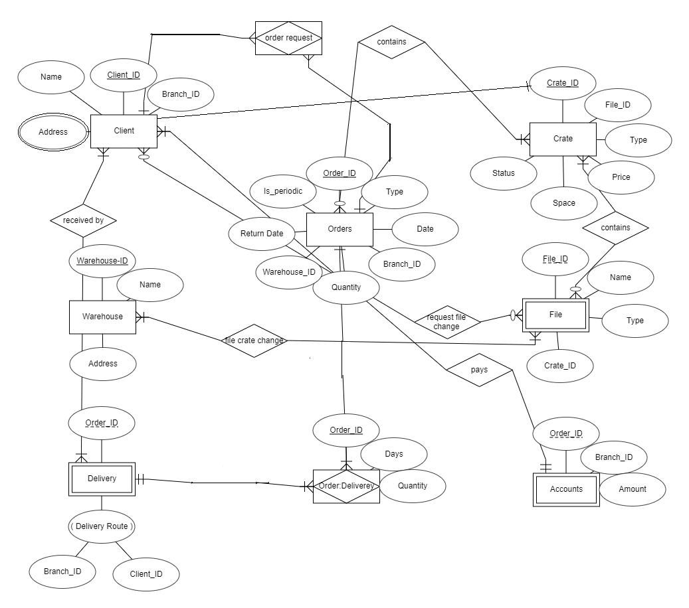

* 1. **Context Diagram**

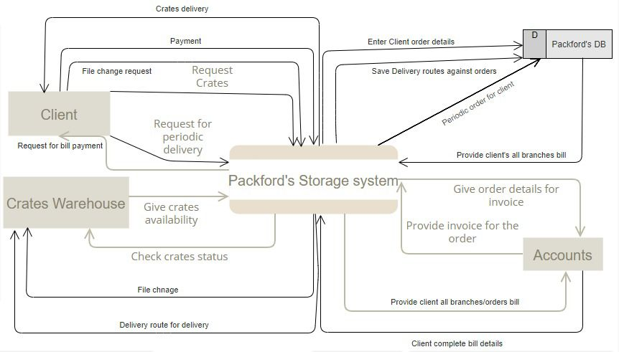

1. **Unified Modeling Language – Design**
   1. **Use Case**

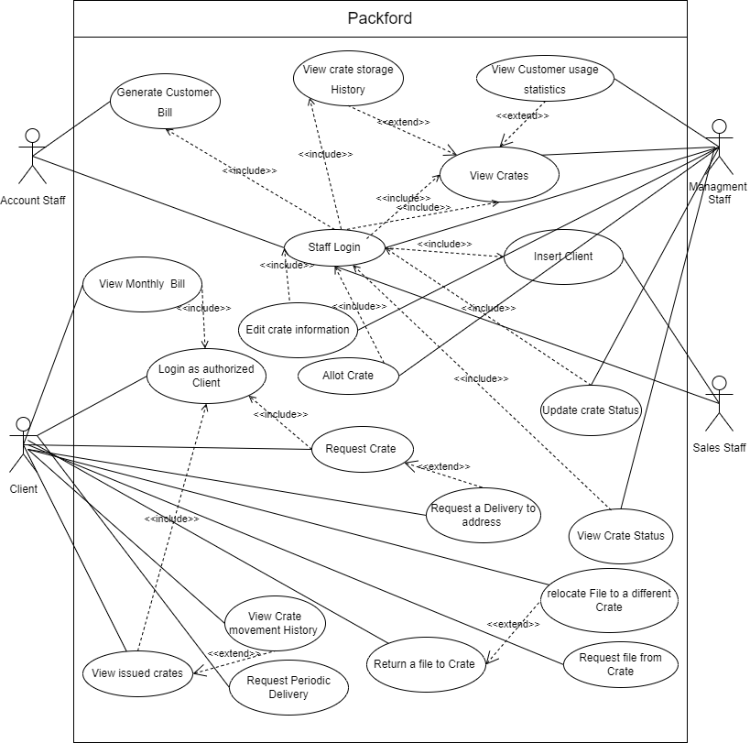

* 1. **Class Diagram**

* 1. **Sequence Diagrams**
     1. **Add/Insert Client**

* + 1. **View Monthly Bill**

* + 1. **View Crate Usage Statistics**

* + 1. **Customer Login**

* + 1. **Generate Customer Bill**

* + 1. **Request Crate**

* + 1. **Request File from Crate**

* + 1. **Return File to Crate**

**Staff Login**

1. **Design Patterns**

In our design we have used **5 main GRASP** pattern. First, to introduce **polymorphism** we have made a generic User class. This will serve as a parent class to Customer and Staff Class. Both type of users has some common attributes such as name, username, and password. The Packford class can now have a users array having all information about different users. Introducing this will make it easier to add new users to the system with different roles with no effect on the existing clients and staff. Adding new functionality will become easier.

The system design in designed to have **less coupling** and **tight cohesion**. To achieve this all the functions related to all major entities are placed with in the same class. There is very little dependence of classes between each other. The **Creator pattern** is utilized in the design. The responsibility of creation of clients, orders and warehouse information is the responsibility of the Packford Class. In this way the aggregation relationships are translated into creator pattern. Fabrication is utilized to all the major tasks such as order creations, editing users and crate information.

The design is created keeping all the object-oriented guidelines in consideration. All the classes have concrete functionalities associated to them. The necessary functions to manipulate data for each class are kept in the same class to introduce cohesion in the design. The role of each class is unique and contained.

To design the Database class of PackFord database **singleton design pattern** is used. Logically there should be only a single Database instant. Every time database object is needed the same object should be returned. In this way multiple copies of the database class won’t be created. To implement the singleton pattern in the code the constructor of singleton object will be kept private. Constructor method of singleton will be declared private. Another method getDB () will be public and can be used to access the Database instant. In this way no class can create a new instant of the class Packford Database. Once an instant of the class is created it will be used universally and a reference to this object will be returned whenever any class tries to create a database instant.

One of the major and most common operation in Packford system is the order generation. One order have multiple objects associated with it such as crates, files information, delivery information. Additionally warehouse information like shelf and address where the order is stored. Client information and some additional information regarding order such as price. To make a flexible solution for various object creation Builder pattern is used. The introduction of Builder pattern will hide all the complex object creation details. Builder class will ensemble and create the complex object of order.

Builder pattern will help to create multiple representation of the order that is needed in the Packford system. For example, the user can order crates and can also request a collection from a delivery address. To fulfill all the required functionality an Order builder class in introduced that will take care of the complexities and object creation details that are required for an order. To implement Builder design pattern in the code A Order Builder class is introduced. It contains functions for all types of orders that can be generated in the system and a single function call will take care of all the recursive object creation that is needed for an order.

1. **System Prototype**
   1. **Login Page**

* 1. **Add Client**

* 1. **Create Order**

